Thursday, 1st October 2009
Mr. Aleksandar Spasenovski visits the European Parliament in Brussels
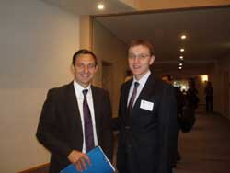
The Co-Chairman of the Joint Parliamentary Committee Republic of Macedonia – EU (JPC - Republic of Macedonia - EU), Aleksandar Spasenovski, who is visiting Brussels, had a meeting with his colleagues from the European Parliament - the Members of the Delegation to the Joint Parliamentary Committee Republic of Macedonia - EU, as well as with other Euro-Parliamentarians.
Mr. Spasenovski met with Jorgo Chatzimarkakis, who has recently been elected Co-Chairman of JPC, the Deputy Vice Co-Chairman Jiří Havel, Ivo Vajgl, Ani Podimata, Heidi Rühle, Zoran Thaler, the Rapporteur for Macedonia in the EP, Monica Maccovei, Marina Yannakoudakis, Milan Zver and Michael Kastler, as well as with representatives of the European Committee.
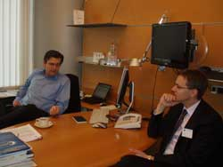
Mr. Spasenovski informed the MEPs about the activities of the JPC and discussed the issues of common interest of the two Parliaments that are especially important for the Euro-integration process of the Republic of Macedonia.
The MEPs, most of whom are well informed about the situation in the Republic of Macedonia and the Balkans, expressed their positive attitude regarding the process of reforms implemented in the Republic of Macedonia, especially in the area of judiciary and internal affairs, necessary for liberalization of the visa regime. In the Region Macedonia is a leader in this field, and the MEPs reiterated that they will continue to support the Republic of Macedonia on its path towards the EU.
During the discussions, all the MEPs pointed out that the positive spirit and the exchange of views on the different topics will continue at the next meeting of JPC.

